THREAT INTELLIGENCE SYSTEM

Project Team Members
Sr. No | Name | Registration No
1 | Muhammad Madni | B23F0309SE065
2 | Muhammad Wasif | B23F0396SE006
3 | Muhammad Zohaib | B23F0515SE005
4 | Duad Latif | B23F0195SE011
5 | Haneea Liaqat Awan | B23F0493SE010

1. Introduction
The Threat Intelligence System is a full-stack web-based application developed to collect, manage, and analyze cybersecurity threats using Indicators of Compromise (IOCs). These indicators include IP addresses, domain names, severity levels, and sources of threats.
The system is designed to help security analysts and organizations track potential threats efficiently and maintain a structured database for further analysis. It integrates modern technologies such as Spring Boot, MySQL, and Apache Kafka to ensure scalability, performance, and real-time processing.

2. Objectives
The main objectives of this project are:
- To design and develop a system for managing threat intelligence data
- To store Indicators of Compromise (IOC) in a structured database
- To provide RESTful APIs for communication between frontend and backend
- To implement real-time data streaming using Kafka
- To build a simple and interactive web dashboard
- To demonstrate full-stack development using modern technologies

3. Scope of the System
The system is designed for educational and foundational cybersecurity use. It allows:
- Manual entry of threat data
- Storage and retrieval of IOC records
- Real-time messaging using Kafka
- Visualization of stored data through a web interface
Future extensions can make it suitable for enterprise-level threat monitoring systems.

4. Technologies Used

4.1 Backend
- Java 17
- Spring Boot
- Spring Web
- Spring Data JPA

4.2 Database
- MySQL

4.3 Messaging System
- Apache Kafka
- Zookeeper

4.4 Frontend
- HTML
- CSS
- JavaScript

4.5 Tools & Platforms
- Maven
- Docker (for Kafka & Zookeeper)
- IntelliJ IDEA / VS Code

5. System Architecture
The system follows a layered architecture, ensuring separation of concerns and scalability.

Architecture Layers:
- Presentation Layer (Frontend)
  - User interacts via dashboard
- Controller Layer (REST API)
  - Handles HTTP requests
- Service Layer
  - Contains business logic
- Repository Layer
  - Communicates with database
- Database Layer (MySQL)
  - Stores IOC data

Kafka Integration Flow:
- Kafka Producer → Sends messages
- Kafka Topic → Stores messages
- Kafka Consumer → Processes messages

6. System Modules

6.1 IOC Entity Module
This module defines the structure of threat data.
Attributes:
- IP Address
- Domain Name
- Severity Level
- Source

6.2 REST API Module
Provides endpoints for interaction.
Method | Endpoint | Description
POST | /ioc | Save IOC data
GET | /ioc | Retrieve all IOC data

6.3 Service Layer
- Implements business logic
- Validates and processes data
- Coordinates between controller and repository

6.4 Repository Layer
- Uses Spring Data JPA
- Performs CRUD operations
- Connects directly to MySQL database

6.5 Kafka Module
- Producer sends threat data to Kafka topic
- Consumer listens and processes messages
- Enables real-time threat handling

6.6 Frontend Dashboard
A simple UI that allows:
- Input of IOC data
- Viewing stored data in table format
- Interaction with backend APIs

7. Database Design

Table: ioc_data
Field | Type | Description
id | Long | Primary Key
ip | String | IP Address
domain | String | Domain Name
severity | int | Threat Severity
source | String | Data Source
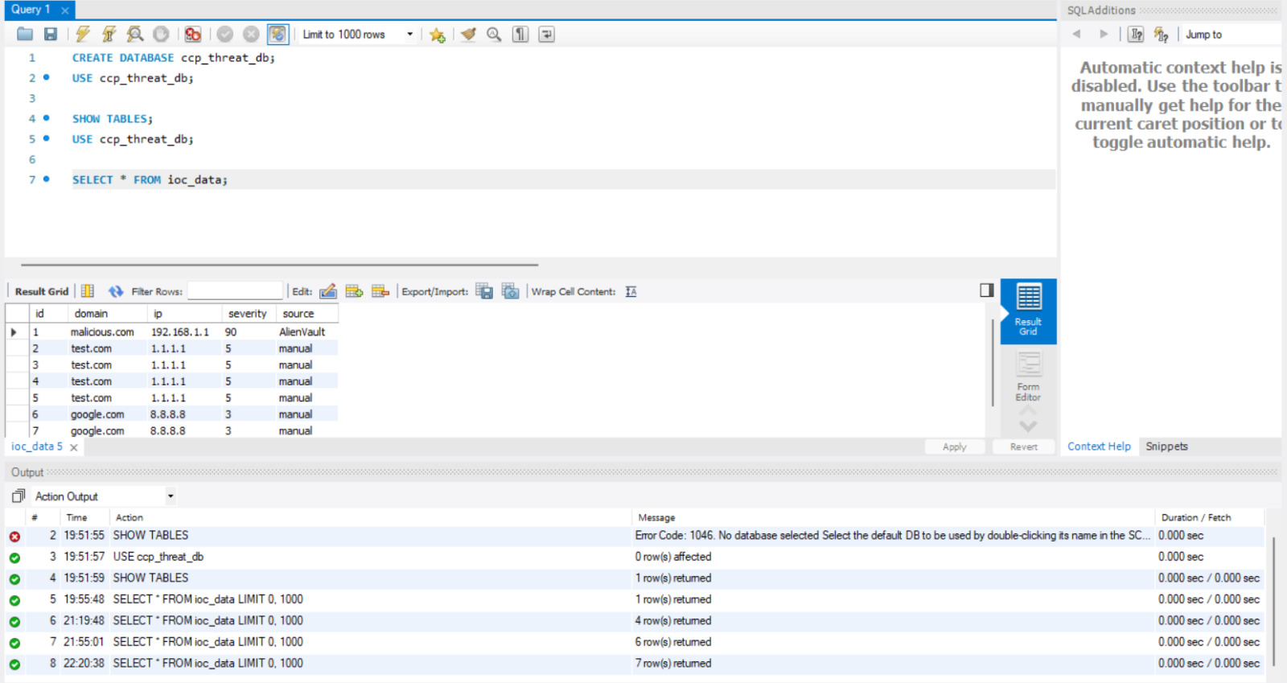

8. System Workflow
- User enters IOC data through dashboard
- Data is sent to Spring Boot REST API
- Backend processes and stores data in MySQL
- Kafka producer sends message to topic
- Kafka consumer processes message
- Stored data is displayed on frontend

9. Features of the System
- Add and manage threat intelligence data
- View all stored threats
- REST API-based communication
- Real-time data streaming with Kafka
- Persistent data storage using MySQL
- Simple and user-friendly interface

10. Sample Output
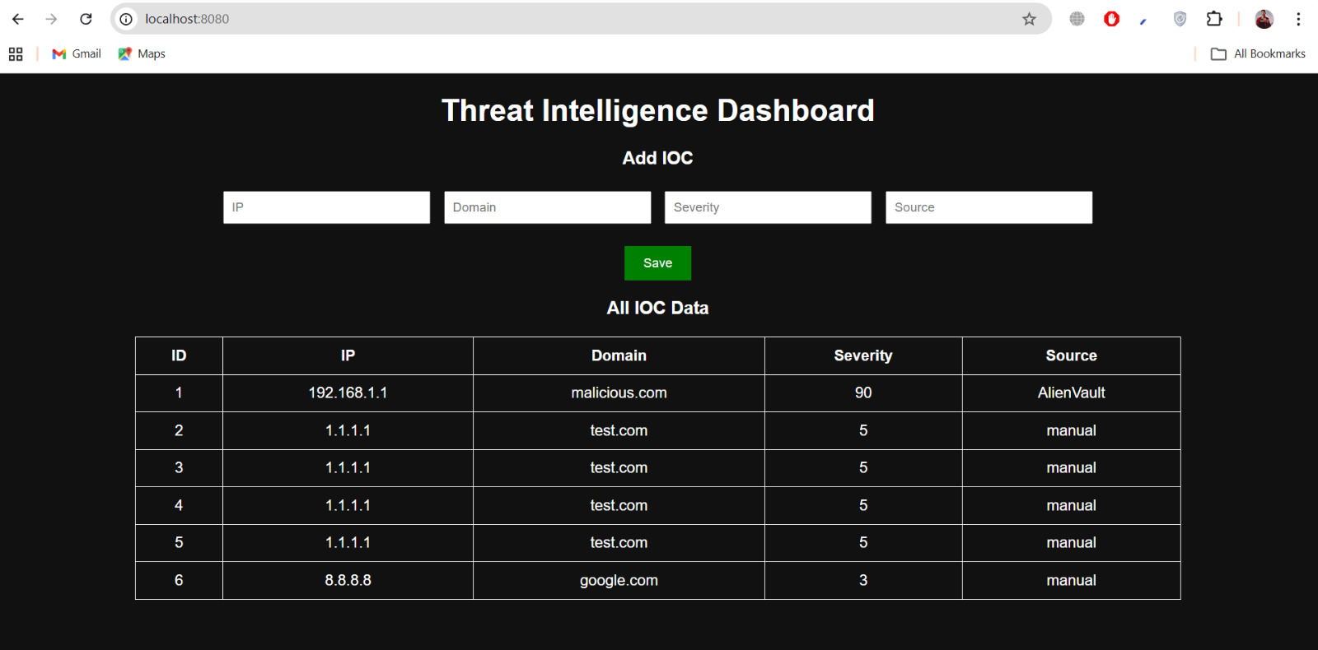
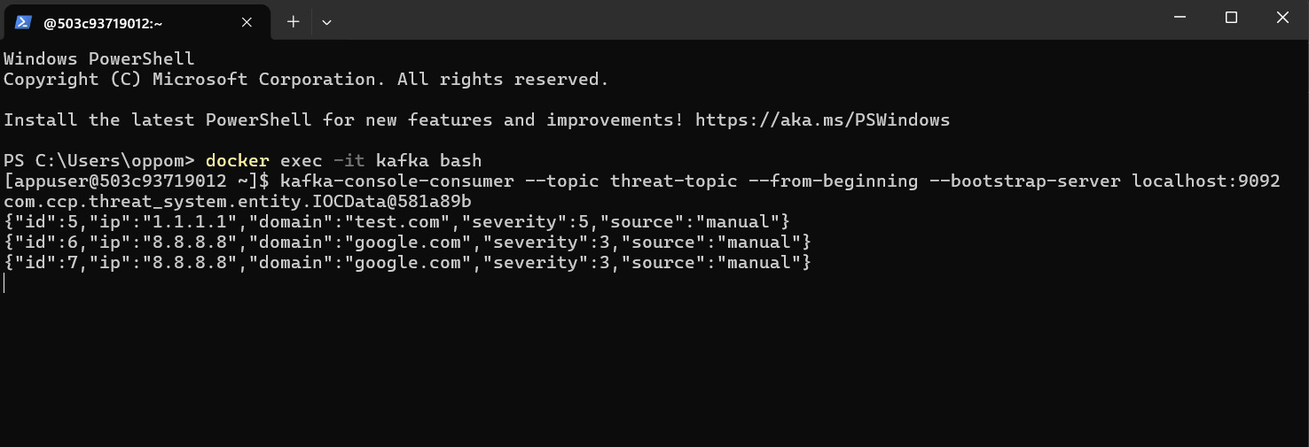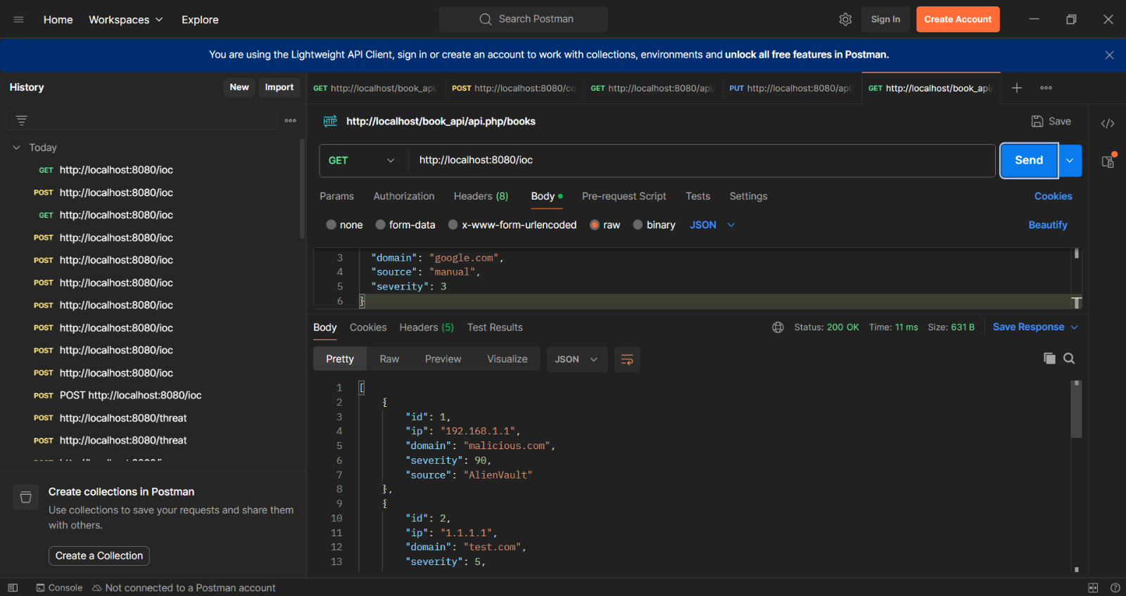

11. Testing
The system can be tested using:
- Postman (for API testing)
- Browser (for frontend testing)
- MySQL Workbench (for database verification)

12. Limitations
- No authentication system
- Manual data entry only
- No real-time UI updates
- Basic frontend design

13. Future Improvements
- Real-time updates using WebSocket
- AI/ML-based threat classification
- JWT-based authentication and security
- Advanced dashboard with analytics
- Role-based access control
- Integration with external threat APIs

14. Conclusion
The Threat Intelligence System successfully demonstrates the integration of backend, database, messaging system, and frontend into a complete full-stack application.
It provides a strong foundation for building advanced cybersecurity tools and highlights the importance of real-time data processing and structured threat management systems.
This project enhances understanding of:
- Spring Boot development
- Database integration
- Kafka messaging systems
- Full-stack architecture

15. References
- Spring Boot Documentation
- Apache Kafka Documentation
- MySQL Documentation
- Java Official Documentatio

